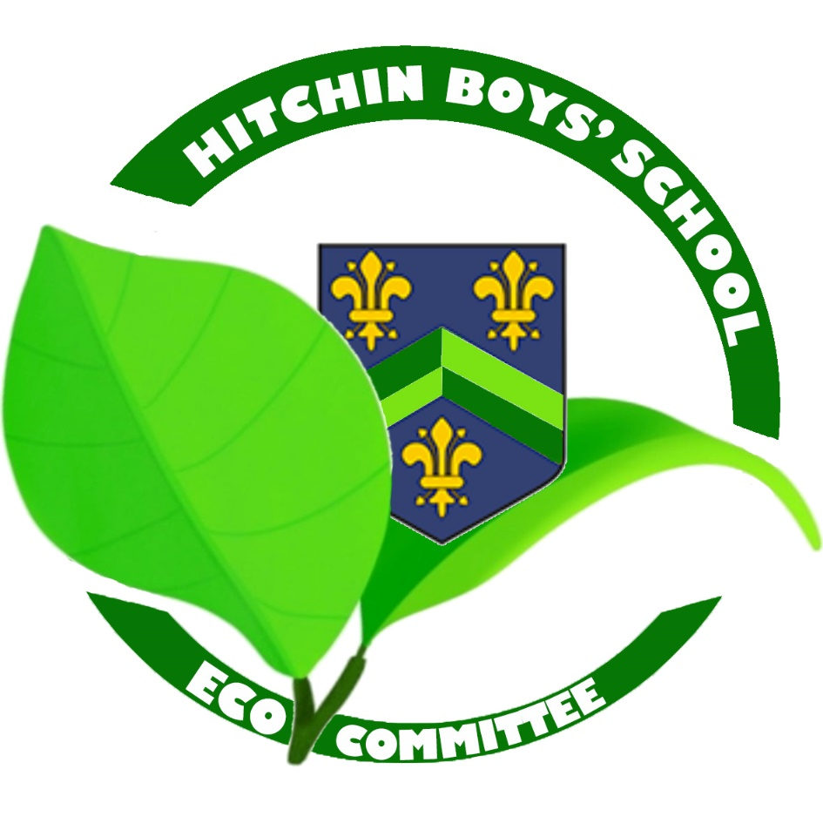

**We believe in a sustainable future for Hitchin Boys’ School.**

**We are fighting to change behaviour and reduce litter in both our school and wider community.**

**We encourage our whole school community to become global citizens so that we all do our bit to protect the future of our planet.**

**We are committed to developing our outdoor areas and to the conservation of biodiversity within our school environment.**